FRONT DESK ASSISTANT

A Project Report

submitted in partial fulfillment for the requirements of the award of the

degree of

BACHELOR OF TECHNOLOGY

IN

INFORMATION TECHNOLOGY

Submitted by

VIKAL RATHI (1602913123)

Supervised by

Dr. AJAY AGARWAL



DEPARTMENT OF INFORMATION TECHNOLOGY
KIET GROUP OF INSTITUTIONS, GHAZIABAD, UTTAR PARDESH
(Affiliated to Dr. A. P. J. Abdul Kalam Technical University, Lucknow, U.P., India)

Session 2019-20

DECLARATION

I declare that

a. The work contained in this report is original and has been done by us under the
guidance of our supervisor.

b. The work has not been submitted to any other institute for any degree or diploma.

c. I have followed the guidelines provided by the institute to prepare the report.

d. I have conformed to the norms and guidelines given in the ethical code of conduct
of the institute.

e. Wherever I have used materials (data, theoretical analysis, figures and text) from
other sources, I have given due credit to them by citing them in the text of the report
and giving their details in the references.

Signature of the student
Name: VIKAL RATHI
Roll number: 1602913123

Place: KIET Group of Institutions, Ghaziabad
Date:

i
CERTIFICATE

This is to certify that the project entitled “FRONT DESK ASSISTANT” , submitted by Vikal Rathi in the Department of Information Technology of KIET Group of Institutions, Ghaziabad, affiliated to Dr. A. P. J. Abdul Kalam Technical University, Lucknow, Uttar Pradesh, India, is a record of bonafide project work carried out by her under my supervision and guidance and is worthy of consideration for the award of the degree of Bachelor of Technology in Information Technology of the Institute.

Signature of Supervisor:
Name of Supervisor: Dr. Ajay Agarwal
Date:

ii

CONTENT

Page No.

Declaration i

Certificate ii

List Of Acronyms iii

Abstract iv

Chapter 1: INTRODUCTION 1

1.1 Introduction 1

1.1.1 Scopes 1
1.1.1.1 In scopes

1.1.1.2 Out of Scope

1.2 Problem Definition 1

1.3 Project Overview 2

1.4 Objectives 2

1.5 Motivation 2

Chapter 2 :FEASIBILITY STUDY 3

2.1 Existing System 3

2.2 Proposed System 3

2.3 Feasibility Study 3

2.3.1 Operational Feasibility 3

2.3.2 Technical Feasibility 3

2.3.3 Financial and Economic Feasibility 4

2.3.4 Organizational Feasibility 4

Chapter 3: SYSTEM ANALYSIS AND DESIGN 5

3.1 Requirement Analysis 5

3.1.1 Functional Requirements 6

3.1.2 Non Functional Requirements 9

3.1.3 Performance Requirements 9

3.1.4 Hardware & Software Requirement 10

3.2 Diagrams 11

3.2.1 Data Flow Diagram 11

3.2.2 Entity-Relationship Diagram 12

3.3 Design 13

3.3.1 Class Diagram 14

3.3.2 Use Case Diagram 15

3.3.3 Sequence Diagram 16

Chapter 4: IMPLEMENTATION 18

4.1 Project Description 18

4.1.1 User Interface 18

4.1.2 Database 25

Chapter 5: CONCLUSION 26

REFERENCES 26

List of acronyms

- FDA -Front Desk Assistant
- API -Application Program Interface
- WWW - World Wide web
- HTML - Hyper Text Markup Language
- GUI - Graphical User Interface
- DFD - Data Flow Diagram
- ERD - Entity Relationship Diagram

iii

Abstract

This project aims at smartly storing and updating the visitor's details for any institution when a visitor visits the place his/her details will be fetched/extracted from the adhaar card through our mobile application. Details then will be submitted to the database and will be automatically shown on the desktop of the receptionist, the variable fields like "reason of visit", "whom to meet", will be entered by the receptionist and the data will be saved.When the user will visit again, there is now no need of rescanning the adhaar as the user was already created at the first visit, searching through UID (Adhaar ID) will display the user and the variable fields can be changed according to the need, the count of the visits will be incremented.The admin section is used to create receptionist, and generate an overall report of the visitors.Our objective is to bring a change in society by automating the process of registration and reducing paper usage at any institutions by Front Desk Assistant(FDA).

iv

CHAPTER 1
INTRODUCTION

1.1 Introduction
The purpose of this document is to present a detailed description and requirements of the Web Application which shall be used for registration at an institute or an organization. It will explain the purpose and features of the system, the requirements of the system, the interfaces of the system, what the system will do and the constraints under which it must operate. This document is intended for both the admin and the operator (receptionist). It also tells us about the assumptions we have made to make this web application and the languages and platforms that it uses for the development of the application. It contains various figures such as system process flow diagram, block diagram and screen layouts of different web pages that we have in our web application.
1.1.1 Scopes
1.1.1.1 In Scope:
We describe what features are in the scope of the software and what are not in the scope of the software
to be developed.
- Module to do registration of (first time) visitor by scanning Aadhar card and extracting details.
- Module to prevent re-registration of people that have already visited once.
- Already registered users should be recognized by key-words searches such as Name and Phone Number.
- Module to update information (if changed) of already registered user.
- Module to migrate the user data from some old system to this new system
- Module to generate the various kinds of reports of interest for admin for last 3 months of data.
- Module for user management by admin

1.1.1.2 Out of Scope:
1. It cannot be used for the registration of Faculty/Administration/Staff-members/Students.
2. The software is not using technology like face recognition, biometric sensor for checking the fake identification of visitors

1.2 Problem Definition

A very common phenomenon observed in our daily life is that whenever we go to an organisation/Institution we write down our name and contact details and every time we visit we have to repeat the same process, as the old records are lost. In similar manner, the notebooks in which the registration is done is lost sometimes ,so the data is lost and maintaining copies of registration is difficult .So there is need of a platform to help to handle this situation.

Page 01 of 26
1.3 Project Overview
This project aims at smartly storing and updating the visitor’s details. This is achieved by extracting details from the Aadhar Card.The proposed Smart FDA will take care of the registration of the visitor’s details at the time of their visit. This system is for recording the visitors’ log. When a visitor visits the organization, number of their visits will be updated accordingly.

1.4 Objective:
The website is developed
- To minimize the wastage of resource like Paper.
- To provide a secure medium for exchange of resources by maintaining the privacy
of users.
- To develop web application for doing user registration at Front Desk/Reception

1.5 Motivation:
A very common phenomenon observed in our daily life is wastage of resources at different institutions, With everyday writing in a notebook when we go to any institutions, We have intended to solve this issue to some extent with the help of our website and mobile application,Our website offers a platform to the institutions to register users easily and manage the records easily. With actors Visitors,Receptionist,Admin.

Page 02 of 26
CHAPTER 2
FEASIBILITY STUDY
2.1 Existing System
In existing systems, we found that there are few institutions which are using there own registration system medium but most of the institutions are still using pen paper based registration system only. There is no diverse platform which can provide the automation of the current pen paper based registration, and issue with the existing system is they are institution based and are not available for all.
2.2 Proposed System
This Proposed system is designed to provide an application and a platform which is free and will be available to all the institutions, Our website offers a platform to the institutions to register users easily and manage the records easily. With actors Visitors,Receptionist,Admin. This is achieved by extracting details from the Aadhar Card. The proposed Smart FDA will take care of the registration of the visitor’s details at the time of their visit. This system is for recording the visitors’ log. When a visitor visits the organization, number of their visits will be updated accordingly.

2.3 Feasibility
Feasibility Study is a preliminary study undertaken to determine and document a project’s viability. The term feasibility study is also used to refer to the resulting document. These results of this study are used to make a decision whether to proceed with the project, or table it. If it indeed leads to a project being approved, it will – before the real work of the proposed project starts – be used to ascertain the likelihood of the project’s success. It is an analysis of possible alternative solutions to a problem and a recommendation on the best alternative.
Operational Feasibility
- User understands our controls
- User understands our symbols
- User reads instructions and help messages
Technical Feasibility

This application can be easily used by anyone so any receptionist will be able to use this application This is technically feasible as it is an application which can be easily downoaded from play store
and the website can be used just going to the url.

Page 03 of 26
Financial and Economic Feasibility

This project is financially and economically feasible as an application and a web platform is needed to access this and any organization and institutions can easily afford it.

Organizational Feasibility
This project is financially and economically feasible as an application and a web platform is needed to access this and any organization and institutions can easily afford it.

Page 04 of 26
CHAPTER 3
SYSTEM ANALYSIS AND DESIGN

3.1 Requirement Analysis

3.1.1 Functional Requirements

Home Page
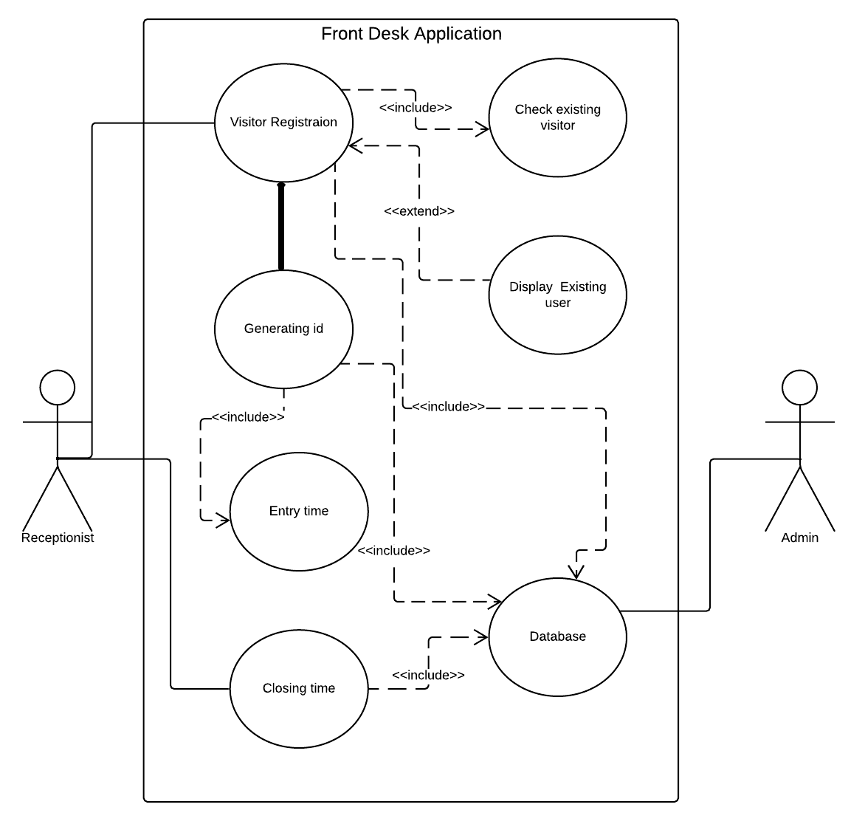
Figure 3.1
Figure 3.1 shows the flow Diagram of the project.
Page 05 of 26
Registration Page

Overview

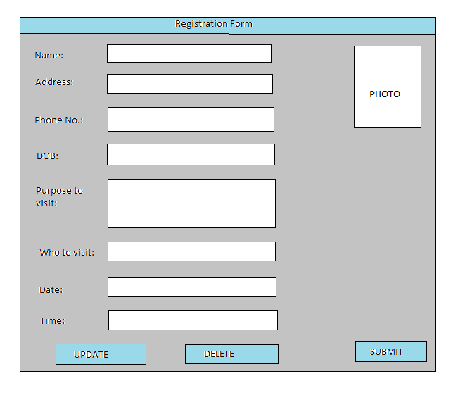
Figure 3.2
Figure 3.2 displays the Registration form

Field Description

S.No | Item Name | Item Description | Field Type | Field  Format | Length | Mandatory
1 | Name | Name of the visitor | Text
2 | Address | Address of the visitor | Text
3 | Photo | Photo of the visitor | JPEG
4 | Phone No | Phone No of the visitor | Numeric
5 | DOB | DOB of the visitor | Date
6 | Purpose to visit | Reason to visit the organization | Text
7 | Date | Date of visiting | Date
8 | Time | Time of visit | Time
9 | Update | Update details | Button
10 | Submit | Submit registration form | Button
Table 3.1
Table 3.1 shows the field description of the project
Page 06 of 26

Use Case

Use Case ID: | Registration Page
Use Case Description | Displays details of visitor and allows to update them
Preconditions: | Visitor must carry the Aadhar Card
Normal Flow: | Form is auto filled from the information extracted from the Aadhar Card
Alternative Flows: | Manual filling of information in case not extracted from the Aadhar Card
Exceptions: | - Visitor not found.  - New visitor does not carry Aadhar Card

Table 3.2

Table 3.2 shows the use case detail for registration section

Admin Page

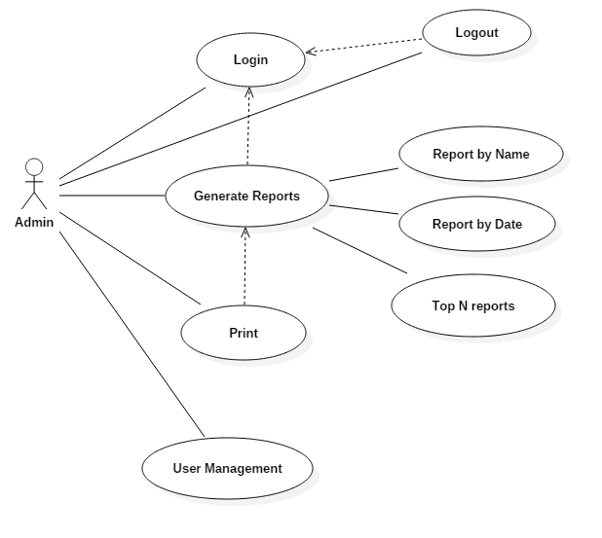

Figure 3.3

Figure 3.3 shows the use case diagram for the project

Page 07 of 26

Use Case

Use Case ID: | Admin Page
Use Case Description | Admin has privileges to extract timely reports based on the database of the organization.
Preconditions: | - Admin must login.  - Admin must know what kind of report is to be generated.
Normal Flow: | - Admin inputs details to generate reports  - Reports can be generated on the basis of intersection of two or more details provided by the admin.  - Reports are generated  - Reports are printed  - New admins are created.
Alternative Flows: | No Alternative flow
Exceptions: | - Admin enters wrong password  - Details entered for report generation are incorrect

Table 3.3
Table 3.3 shows the use case details for admin section

Page 08 of 26
3.1.2 Non Functional Requirements
Performance requirements

The system shall respond to the member within 5-10 seconds from the time of the request submittal. The system shall be allowed to take more time when doing large processing jobs.

Accuracy and Precision

The system should accurately provide real time information taking into consideration various issues.The system shall provide access reliability in range of 99.0% to 99.9%.

Reliability

The system must be reliable due to the importance of data and the damages that can be caused by incorrect or incomplete data. The system will run continuously according to the timings of the organizations/institutions. The proper logging of data is maintained in a log file.

Security

The main security concern is for admin login as he can access critical information. Hence user name and password should be provided to authorized users by the organization to avoid information leak. The system should provide database’s modification only for the receptionist (operator).

Portability:

The System is expected to run under MS Windows.

Usability

The system is easy to learn and easy to remember how to use. System control is intuitive so that the operator doesn’t require to refer a manual frequently. The system uses a web browser as a user interface. The system is user friendly and will support English language only.
Legal
Personal information of the visitors should be protected like Phone number, Aadhaar number etc. and will not be shared with any outsider.

Page 09 of 26

3.1.4 Hardware & Software Requirements

Hardware Requirements

Following is minimum hardware configuration required for deployment.

S. No. | Device name | Operating System | Configuration
1 | Smart Phone | Android | Version 4.4+
2 | Desktop | Windows | Version 7+  RAM 2GB  Processor i2  Hard Disk 20GB
Table 3.4
Table 3.4 shows the hardware requirements for the project

Software Requirements

The software development platform & tools/ technologies used to develop the system are defined as
below

Item | version | Description
MongoDB | 4.0 | Used as a database(NoSql)
JSON | 2.2.0 | Used primarily to transmit data between a server and database.
Django | 2.0 | Used as a framework for development of web app.
Visual Studio | 16.1.3 | Used as an IDE
XML | 1.0 | Used to transfer the visitor’s information from android app to webserver.
Table 3.5
Table 3.5 shows the software requirements of the project.

Page 10 of 26
3.2 Diagrams

3.2.1 Data Flow Diagram

Level 0 Data Flow Diagram

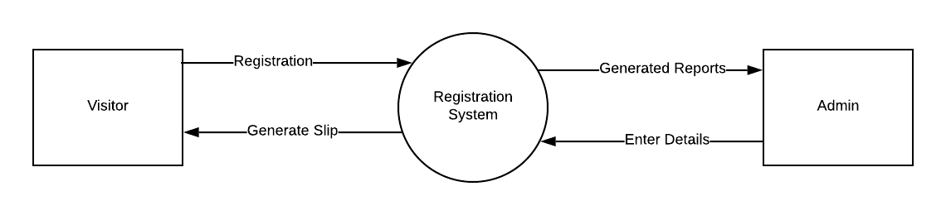

Figure 3.4
The Figure 3.4 shows the Level 0 Data Flow diagram.

Level 1 Data Flow Diagram

Page 11 of 26
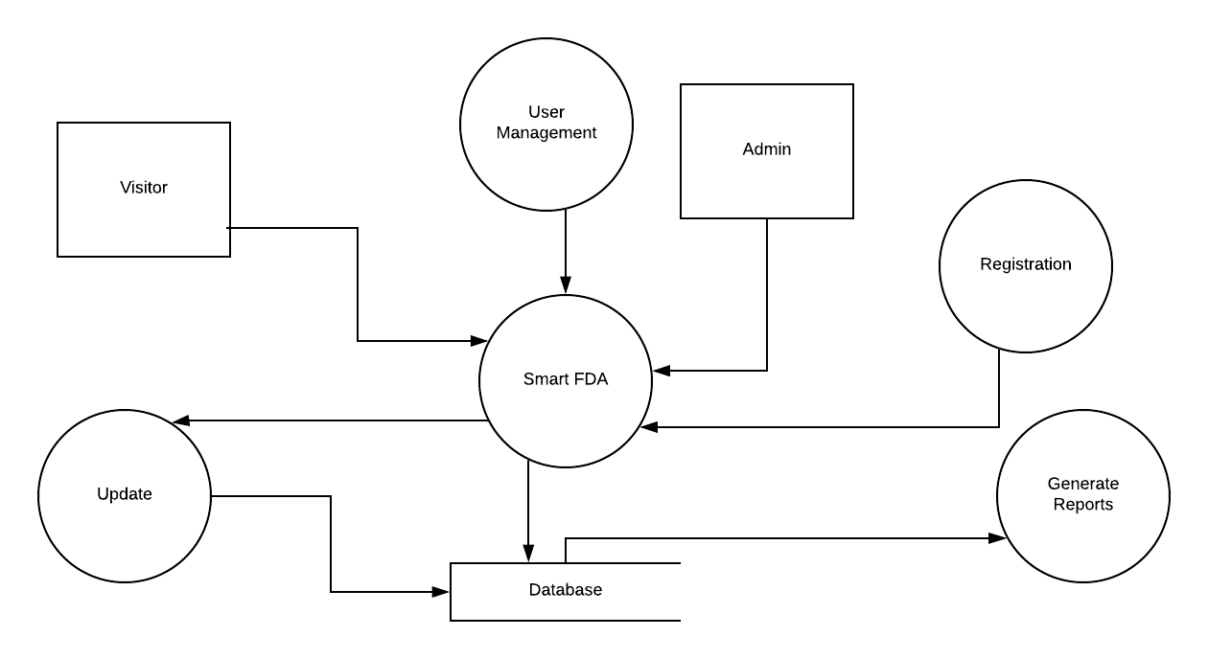
Figure 3.5
The Figure 3.5 shows the Level 1 Data Flow diagram

Page 12 of 26
Level 2 Data Flow Diagram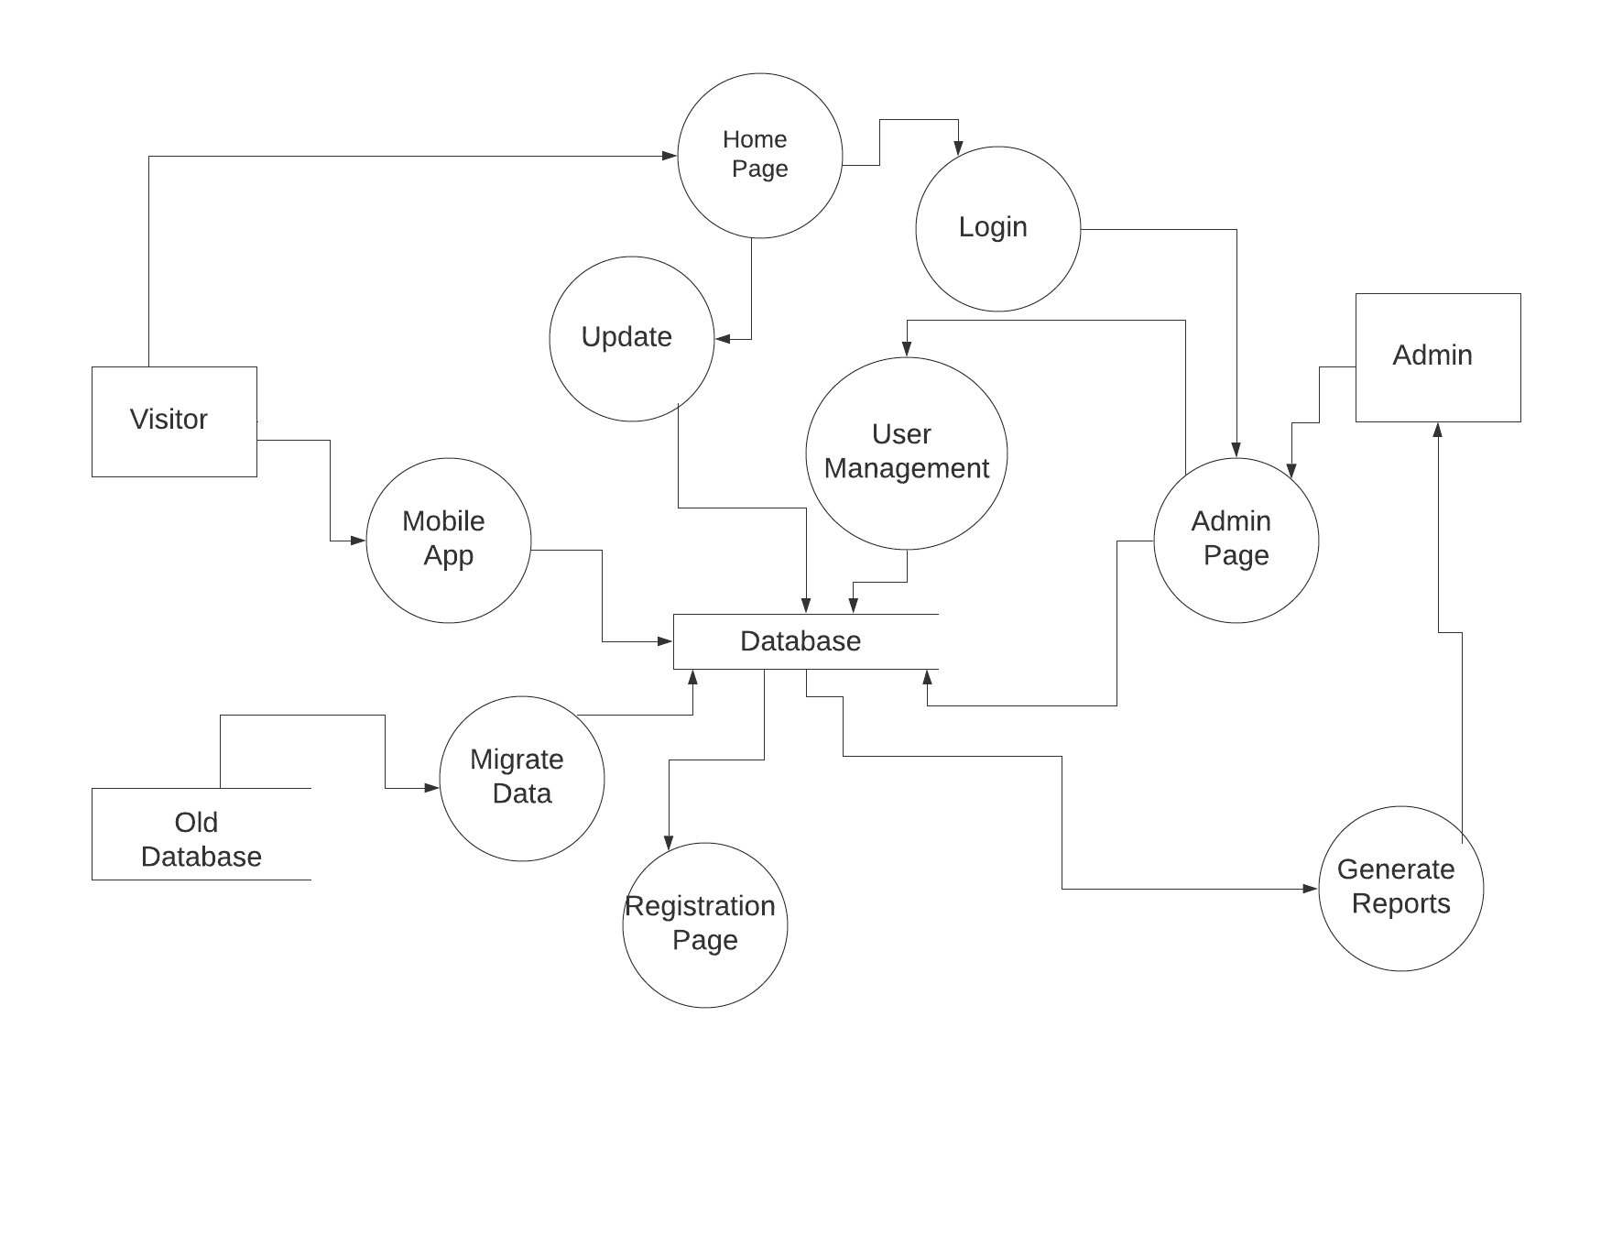

Figure 3.6
Figure 3.6 shows the Level 2 Data Flow diagram

Page 13 of 26
3.2.2 Entity - Relationship Diagram
- For Admin:
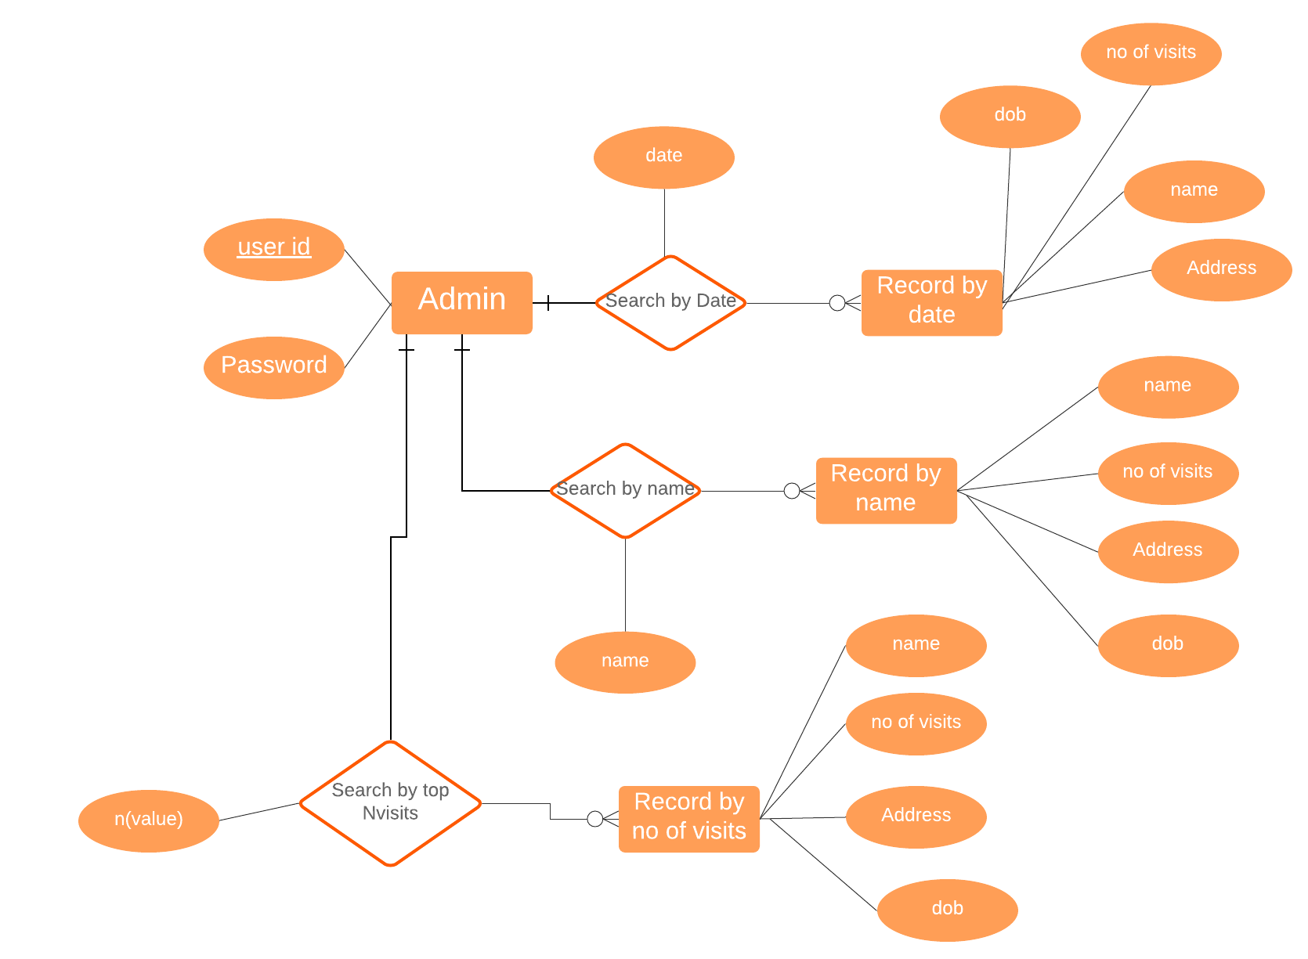

Figure 3.7
Figure 3.7 shows the Entity-Relationship Diagram for the admin

Page 14 of 26
- For Receptionist:
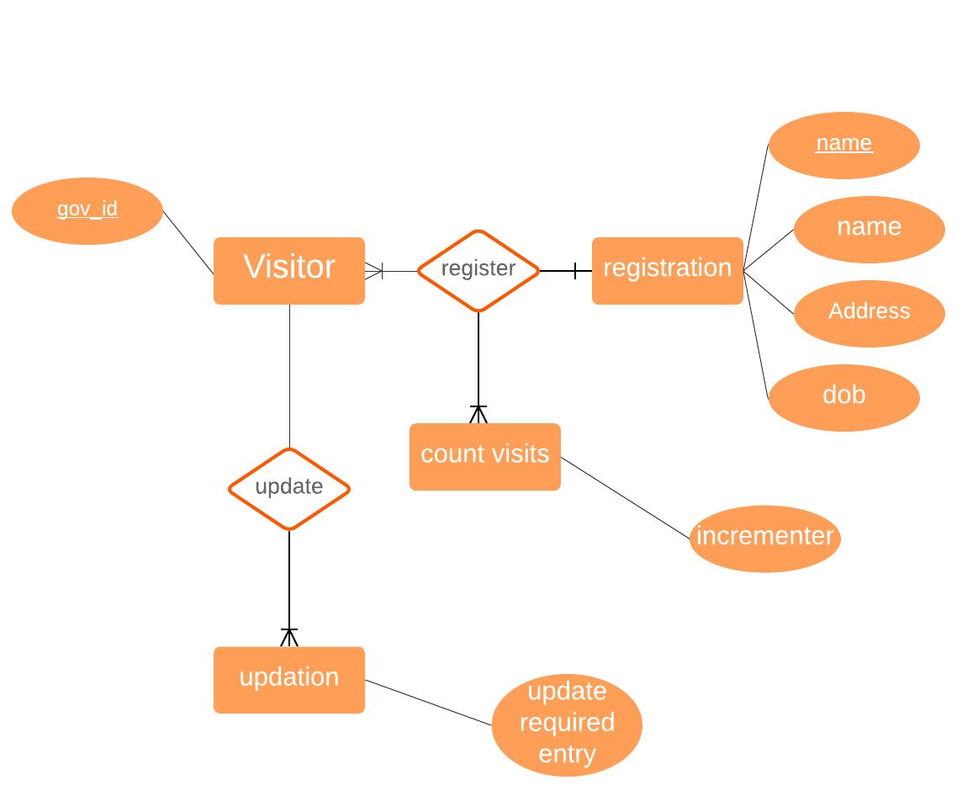
Figure 3.8
Figure 3.8 shows Entity-Relationship Diagram for Receptionist

Page 15 of 26
3.3 Design

3.3.1 Overall Class Diagram
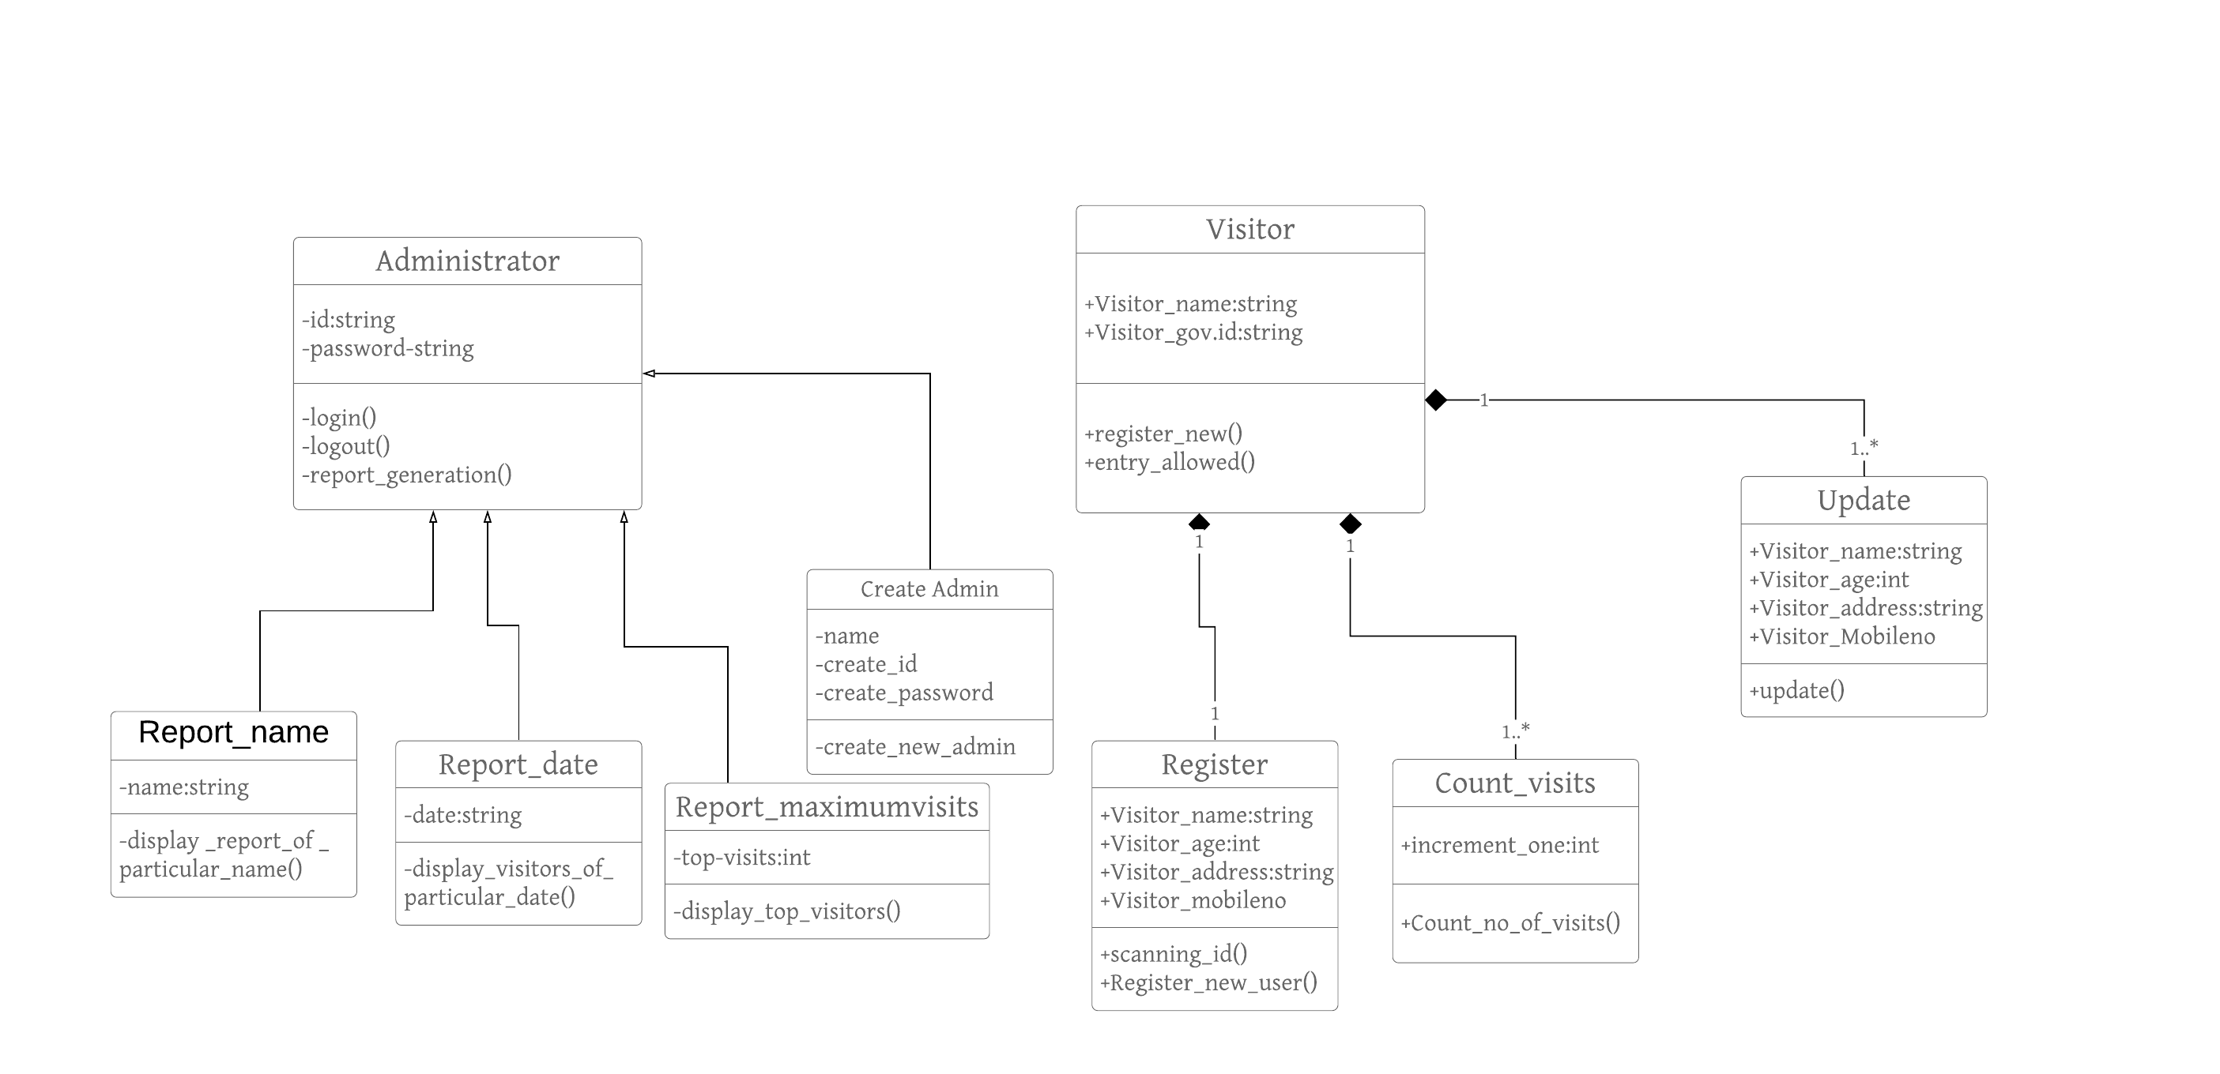
Figure 3.9
Figure 3.9 shows the Overall Class Diagram

Page 16 of 26

3.3.2 Sequence diagram
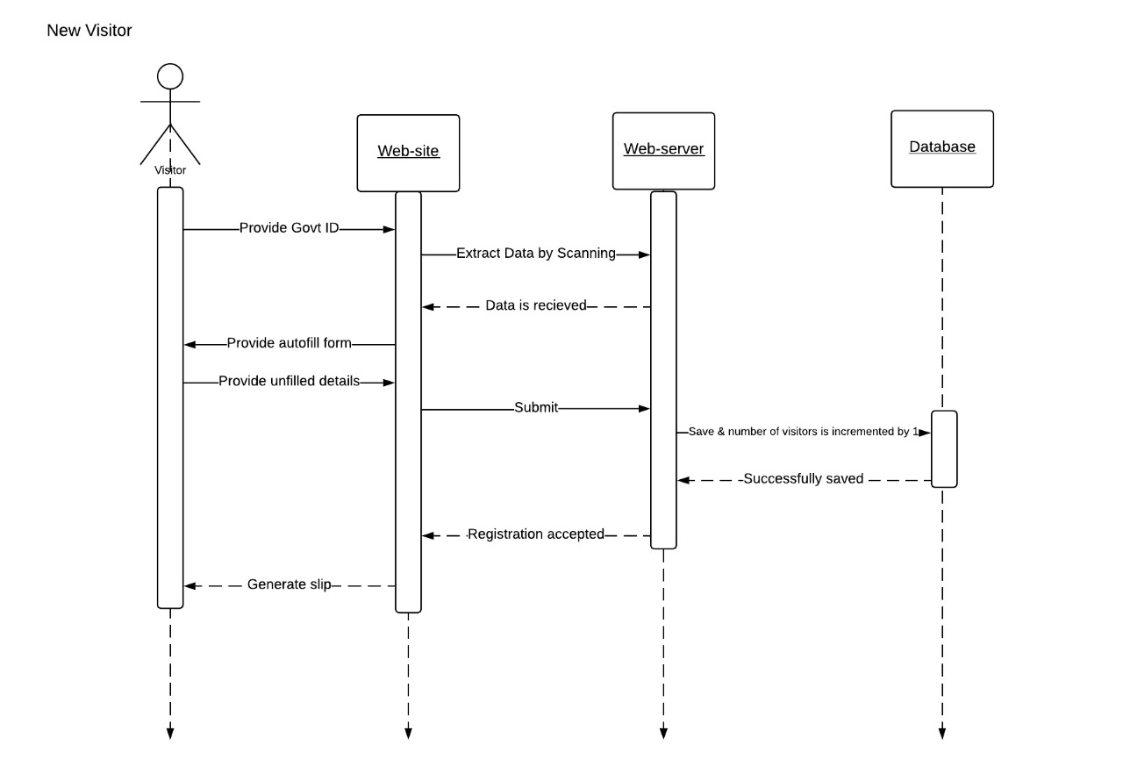
Figure 3.10
Figure 3.10 shows the sequence diagram for new visitor
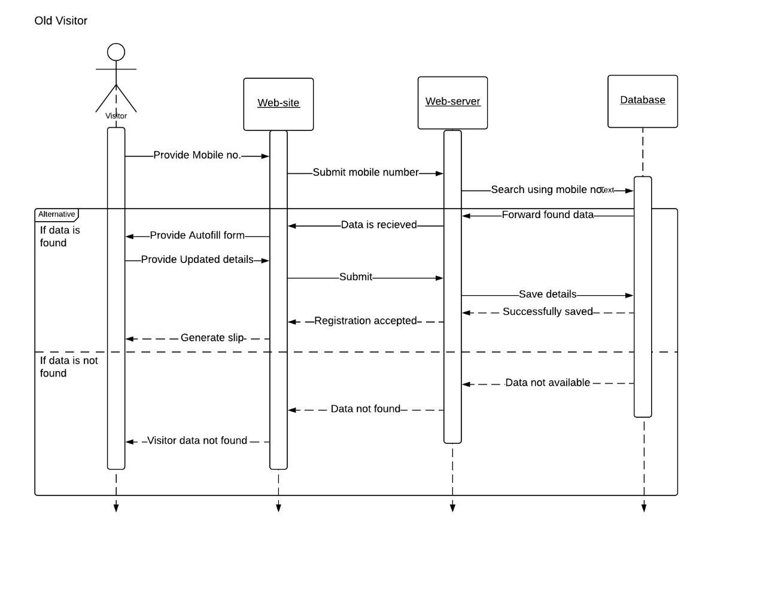
Figure 3.11
Figure 3.11 shows sequence diagram for old visitor
Page 17 of 26
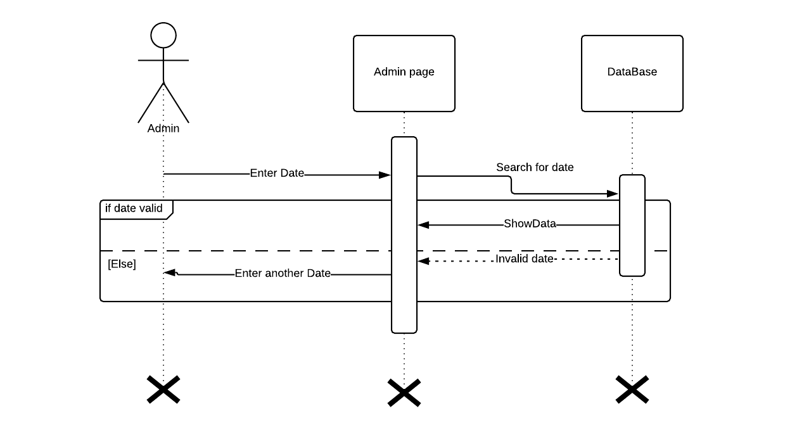
Figure 3.12
Figure 3.12 shows sequence diagram for generating report

Page 18 of 26
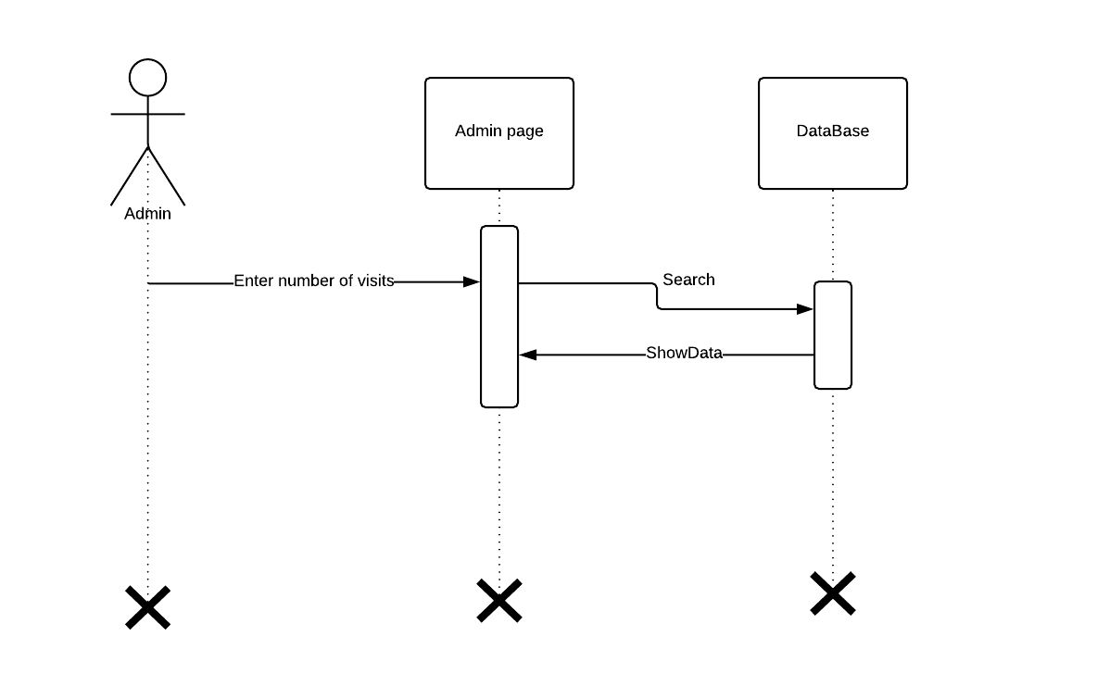
Figure 3.13
Figure 3.13 shows sequence diagram to search number of visit by a visitor

Page 19 of 26
CHAPTER 4
IMPLEMENTATION
4.1.1 USER INTERFACE

Home Page
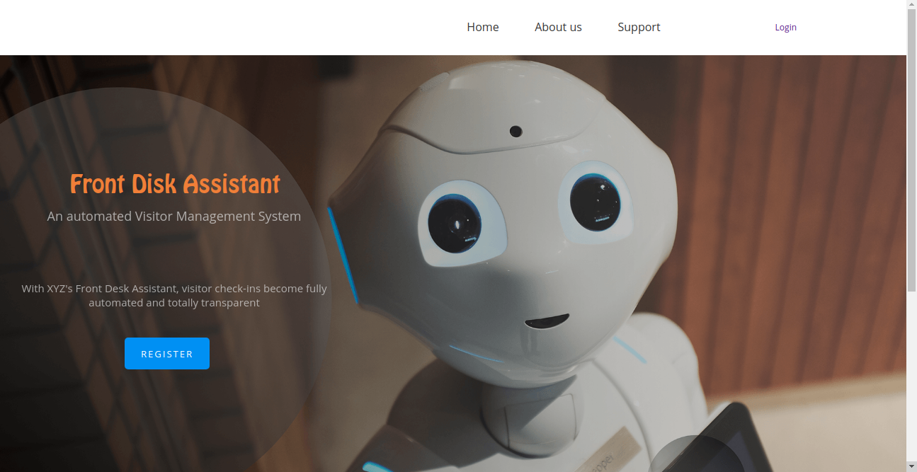
Figure 4.1
Figure 4.1 Shows UI for HomePage

Page 20 of 26
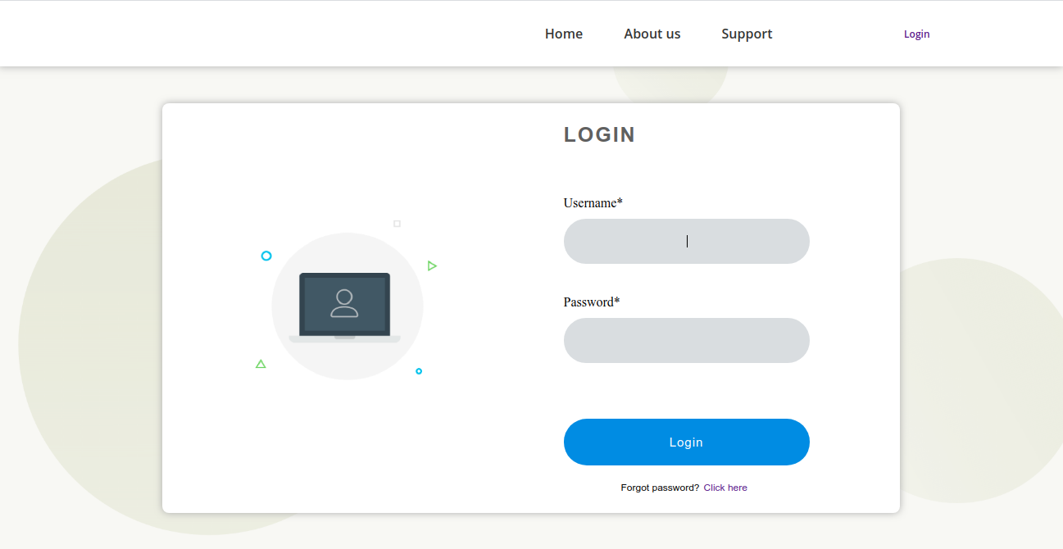
Login page
Figure 4.2
Figure 4.2 shows the Login UI
Admin Dashboard
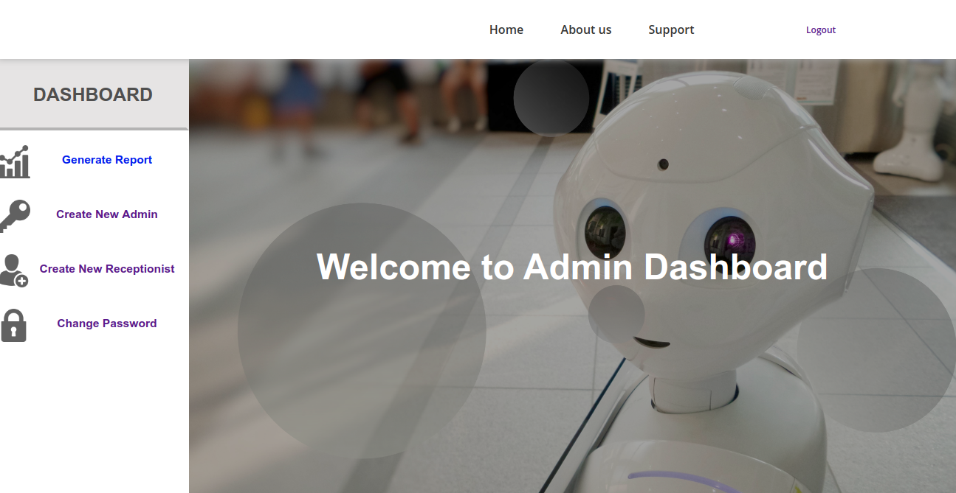
Figure 4.3
Figure 4.3 shows UI for Admin Dashboard

Page 21 of 26
Registration Dashboard
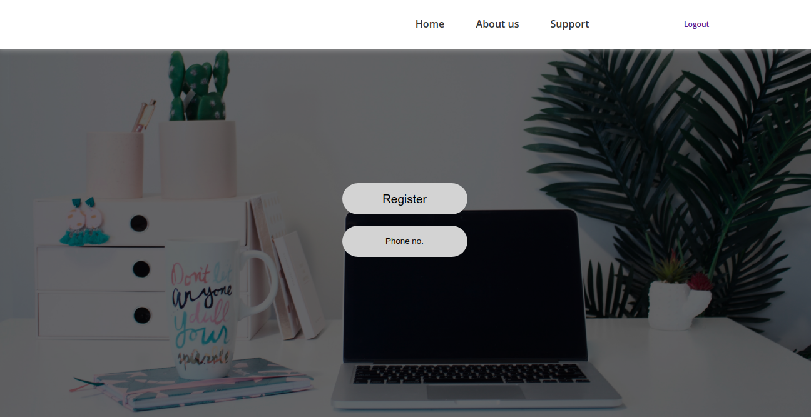
Figure 4.4
Figure 4.4 shows UI for Registration

Page 22 of 26
Mobile Application
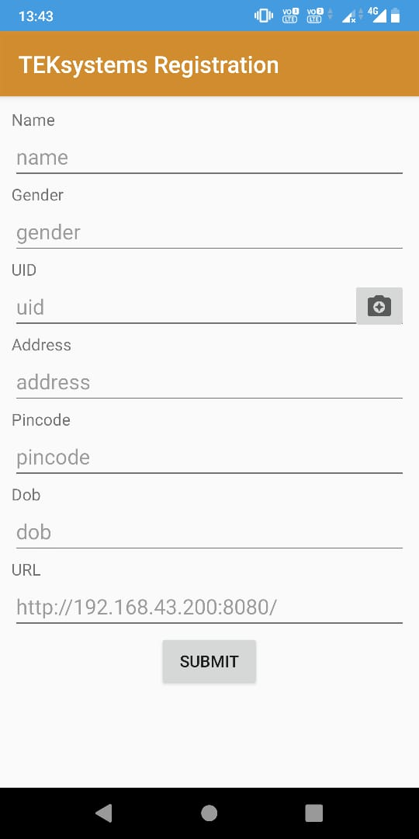

Figure 4.5
Figure 4.5 shows UI for mobile application

Page 23 of 26
Register Receptionist
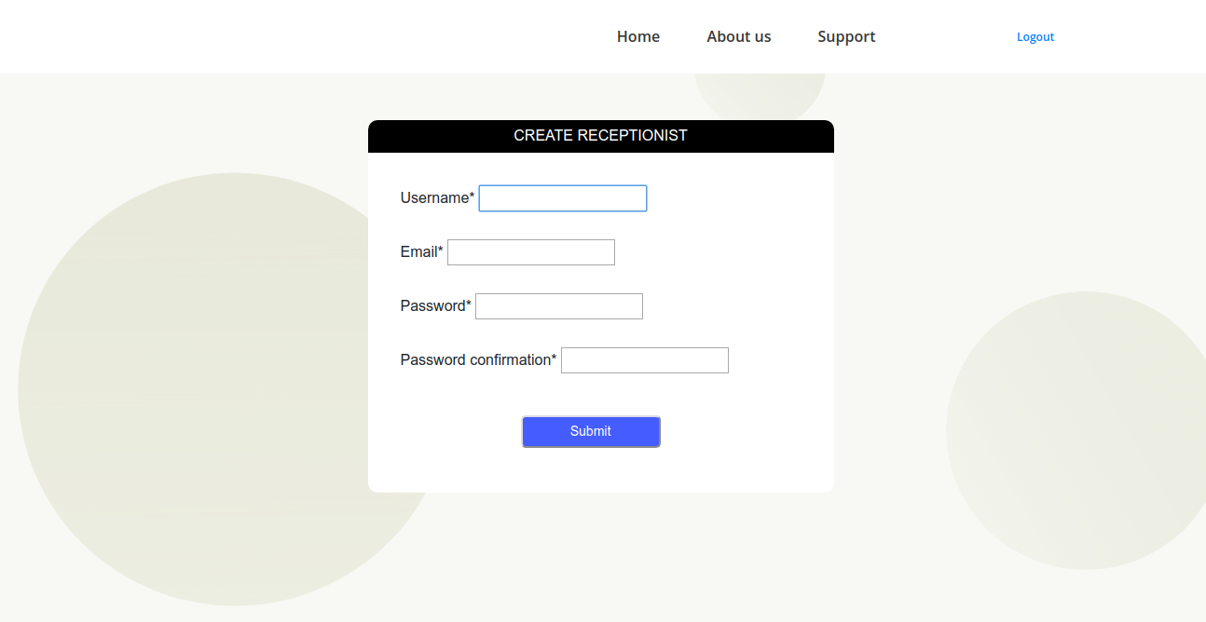
Figure 4.6
Figure 4.6 show the create receptionist form
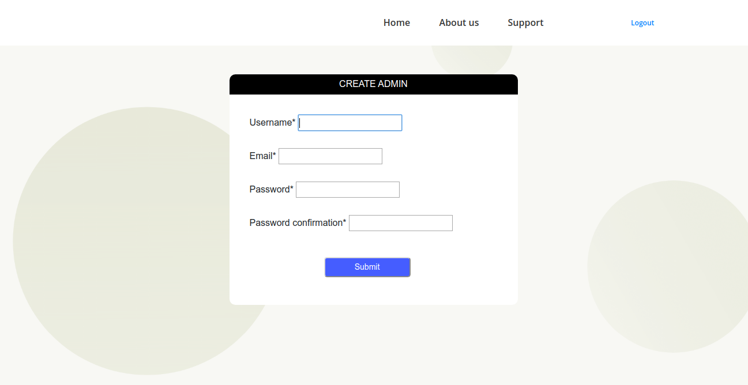
Register Admin
Figure 4.7
Figure 4.7 shows UI for registering admin
Page 24 of 26
4.1.2 DATABASE
No SQL Database (MongoDb) is used in this project.
DATABASE SCHEMA
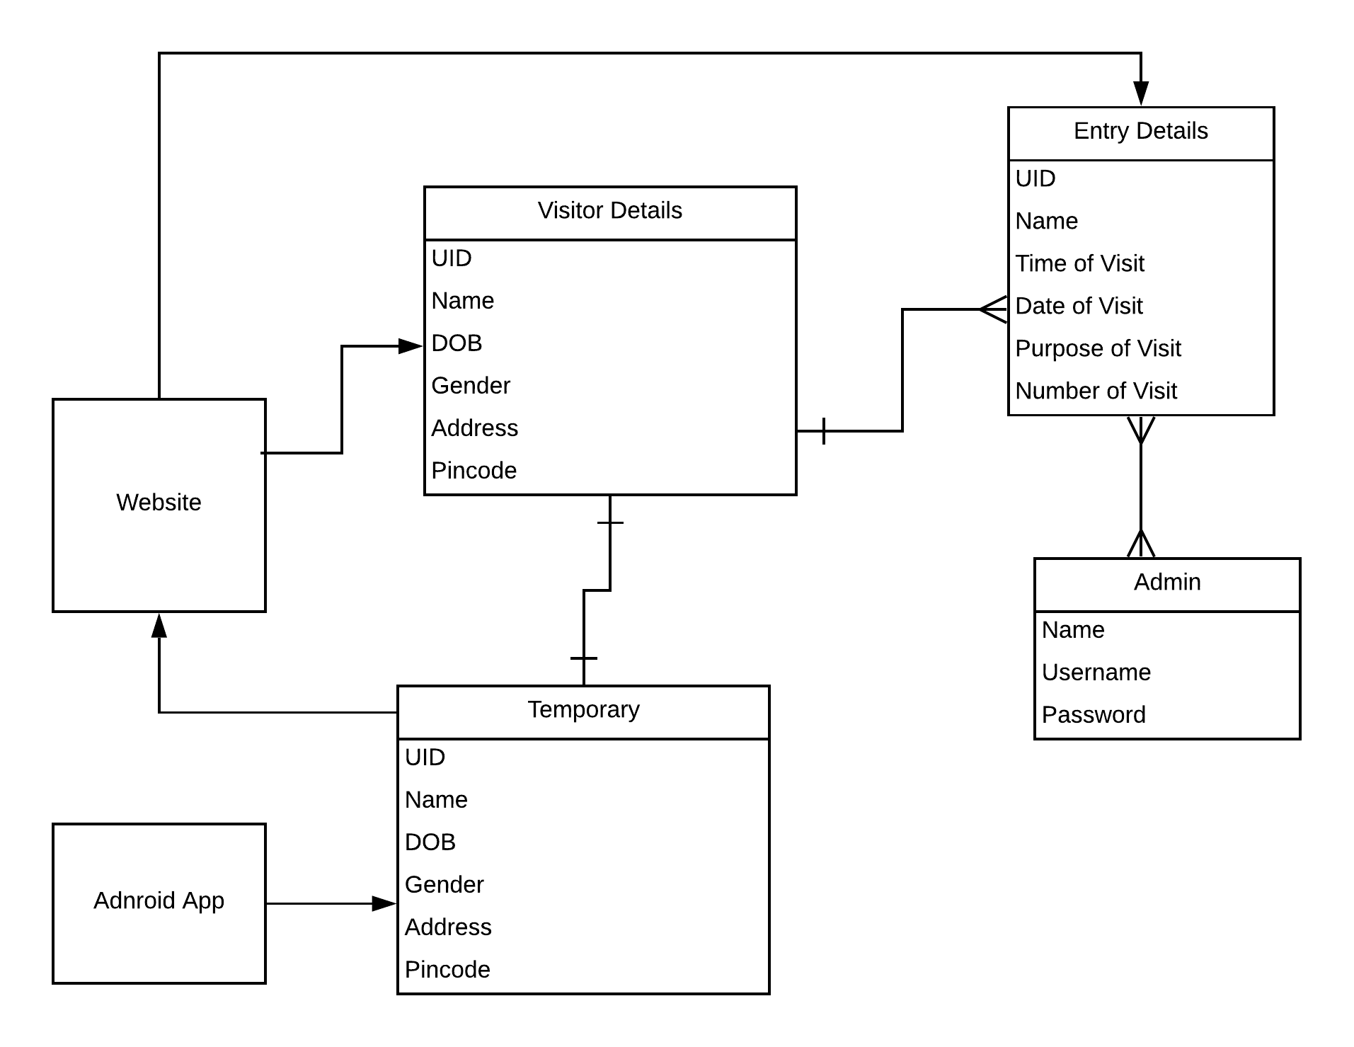
Figure 4.8
Figure 4.8 shows Database Schema.

Page 25 of 26
CHAPTER 5
REFERENCES
- https://developer.android.com/
- https://docs.djangoproject.com/en/3.0/
- https://square.github.io/retrofit/
- https://www.django-rest-framework.org/

Page 26 of 26

